What is locally redundant storage (LRS)

2) Architect storage infrastructure in Azure

a) Choose a data storage approach in Azure

Each data set has different requirements, and it's your job to figure out which storage solution is best. The key factors to consider in deciding on the optimal storage solution are: how to classify your data, how your data will be used, and how you can get the best performance for your application.
application data can be classified in one of three ways: structured, semi-structured, and unstructured. Here, you'll learn how to classify your data so that you can choose the appropriate storage solution.

Structured data
Structured data, sometimes referred to as relational data, is data that adheres to a strict schema, so all of the data has the same fields or properties. The shared schema allows this type of data to be easily searched with query languages such as SQL (Structured Query Language). This capability makes this data style perfect for applications such as CRM systems, reservations, and inventory management.
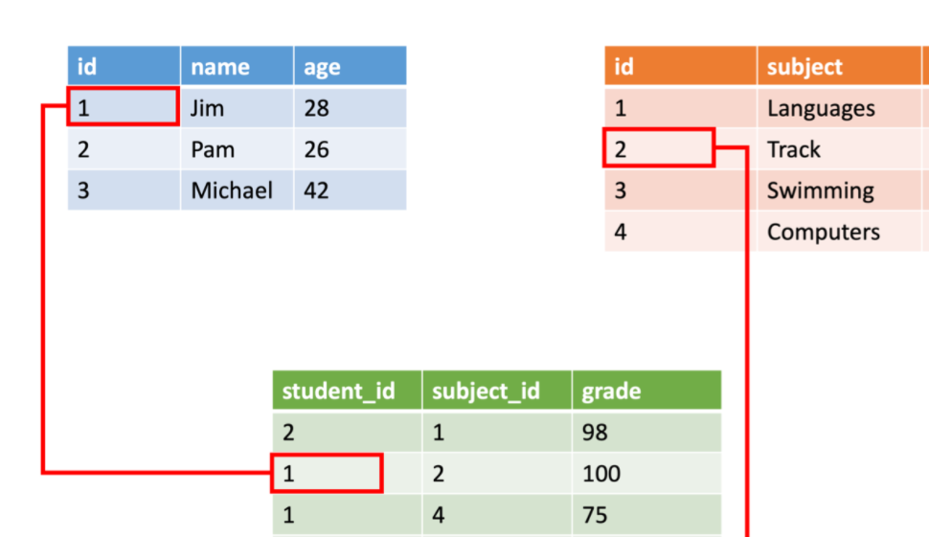

Semi-structured data
Semi-structured data is less organized than structured data, and is not stored in a relational format, as the fields do not neatly fit into tables, rows, and columns. Semi-structured data contains tags that make the organization and hierarchy of the data apparent - for example, key/value pairs. Semi-structured data is also referred to as non-relational or NoSQL data. The expression and structure of the data in this style is defined by a serialization language.
The sender and receiver don’t need to know details about the other system, as long as the same serialization language is used, the data can be understood by both systems.

Common formats
Today, there are three common serialization languages you're likely to encounter:
XML, or extensible markup language, was one of the first data languages to receive widespread support. It's text-based, which makes it easily human and machine-readable. In addition, parsers for it can be found for almost all popular development platforms. XML allows you to express relationships and has standards for schema, transformation, and even displaying on the web.
<Person Age="23">
<FirstName>John</FirstName>
<LastName>Smith</LastName>
<Hobbies>
<Hobby Type="Sports">Golf</Hobby>
<Hobby Type="Leisure">Reading</Hobby>
<Hobby Type="Leisure">Guitar</Hobby>
</Hobbies>
</Person>

JSON – or JavaScript Object Notation, has a lightweight specification and relies on curly braces to indicate data structure. Compared to XML, it is less verbose and easier to read by humans. JSON is frequently used by web services to return data.

{
"firstName": "John",
"lastName": "Doe",
"age": "23",
"hobbies": [
{ "type": "Sports", "value": "Golf" },
{ "type": "Leisure", "value": "Reading" },
{ "type": "Leisure", "value": "Guitar" }
]
}

YAML – or YAML Ain’t Markup Language, is a relatively new data language that’s growing quickly in popularity in part due to its human-friendliness. The data structure is defined by line separation and indentation, and reduces the dependency on structural characters like parentheses, commas and brackets.

firstName: John
lastName: Doe
age: 23
hobbies:
- type: Sports
value: Golf
- type: Leisure
value: Reading
- type: Leisure
value: Guitar

Unstructured data
The organization of unstructured data is ambiguous. Unstructured data is often delivered in files, such as photos or videos. The video file itself may have an overall structure and come with semi-structured metadata, but the data that comprises the video itself is unstructured. Therefore, photos, videos, and other similar files are classified as unstructured data.
Examples of unstructured data include:
- Media files, such as photos, videos, and audio files
- Office files, such as Word documents
- Text files
- Log files

This appears to be a growing trend, and you want to enable customers to filter on "Bluetooth-enabled" shoes in the future. You don't want to go back and update all your existing shoe data with a Bluetooth-enabled property, you simply want to add it to new shoes.

Determine operational needs

Operations and latency
What are the main operations you'll be completing on each data type, and what are the performance requirements?
Ask yourself these questions:
- Will you be doing simple lookups using an ID?
- Do you need to query the database for one or more fields?
- How many create, update, and delete operations do you expect?
- Do you need to run complex analytical queries?
- How quickly do these operations need to complete?

Group multiple operations in a transaction

What is a transaction?
A transaction is a logical group of database operations that execute together.
Here's the question to ask yourself regarding whether you need to use transactions in your application: Will a change to one piece of data in your dataset impact another? If the answer is yes, then you'll need support for transactions in your database service.
Transactions are often defined by a set of four requirements, referred to as ACID guarantees. ACID stands for Atomicity, Consistency, Isolation, and Durability:
- Atomicity means a transaction must execute exactly once and must be atomic; either all of the work is done, or none of it is. Operations within a transaction usually share a common intent and are interdependent.
- Consistency ensures that the data is consistent both before and after the transaction.
- Isolation ensures that one transaction is not impacted by another transaction.
- Durability means that the changes made due to the transaction are permanently saved in the system. Committed data is saved by the system so that even in the event of a failure and system restart, the data is available in its correct state.

OLTP vs OLAP
Transactional databases are often called OLTP (Online Transaction Processing) systems. OLTP systems commonly support lots of users, have quick response times, and handle large volumes of data. They are also highly available (meaning they have very minimal downtime), and typically handle small or relatively simple transactions.
On the contrary, OLAP (Online Analytical Processing) systems commonly support fewer users, have longer response times, can be less available, and typically handle large and complex transactions.

Choose a storage solution on Azure
Choosing the correct storage solution can lead to better performance, cost savings, and improved manageability

Product catalog data
Data classification: Semi-structured because of the need to extend or modify the schema for new products
Operations:
- Customers require a high number of read operations, with the ability to query many fields within the database.
- The business requires a high number of write operations to track its constantly changing inventory.
Latency & throughput: High throughput and low latency.
Transactional support: Because all of the data is both historical and yet changing, transactional support is required.

Recommended service: Azure Cosmos DB
Azure Cosmos DB supports semi-structured data, or NoSQL data, by design. So, supporting new fields, such as the "Bluetooth-enabled" field or any new fields you need in the future, is a given with Azure Cosmos DB.
Azure Cosmos DB supports SQL for queries and every property is indexed by default. You can create queries so that your customers can filter on any property in the catalog.
Azure Cosmos DB is also ACID-compliant, so you can be assured that your transactions are completed according to those strict requirements.

Why not other Azure services?
Azure SQL Database can provide many of the same benefits of Azure Cosmos DB, but it provides little benefit if the structure of your data is changing in different entities, and you cannot pre-define a set of common properties that are repeated in most of the entities. Unlike Azure CosmosDB that indexes every property in the documents, in Azure SQL Database you need to explicitly define what properties from semi-structured documents should be indexed.

Photos and videos
Data classification: Unstructured
Operations:
- Only need to be retrieved by ID.
- Customers require a high number of read operations with low latency.
- Creates and updates will be somewhat infrequent and can have higher latency than read operations.
Latency & throughput: Retrievals by ID need to support low latency and high throughput. Creates and updates can have higher latency than read operations.
Transactional support: Not required

Recommended service: Azure Blob storage
Azure Blob storage supports storing files such as photos and videos. It also works with Azure Content Delivery Network (CDN) by caching the most frequently used content and storing it on edge servers. Azure CDN reduces latency in serving up those images to your users.

Business data
Data classification: Structured
Operations: Read-only, complex analytical queries across multiple databases
Latency & throughput: Some latency in the results is expected based on the complex nature of the queries.
Transactional support: Not required

Recommended service: Azure SQL Database

b) Create an Azure Storage account

Decide how many storage accounts you need

What is Azure Storage?
Azure groups four of these data services together under the name Azure Storage. The four services are Azure Blobs, Azure Files, Azure Queues, and Azure Tables. The following illustration shows the elements of Azure Storage.

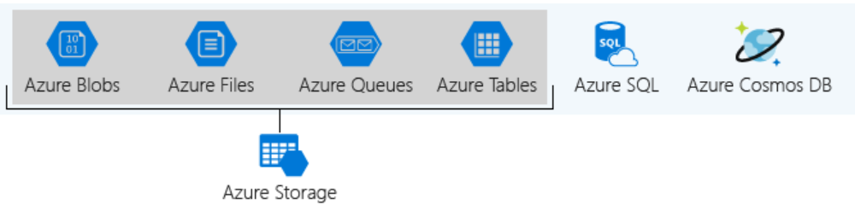
These four data services are all primitive, cloud-based storage services, and are often used together in the same application.

What is a storage account?
A storage account is a container that groups a set of Azure Storage services together. Only data services from Azure Storage can be included in a storage account (Azure Blobs, Azure Files, Azure Queues, and Azure Tables). The following illustration shows a storage account containing several data services.
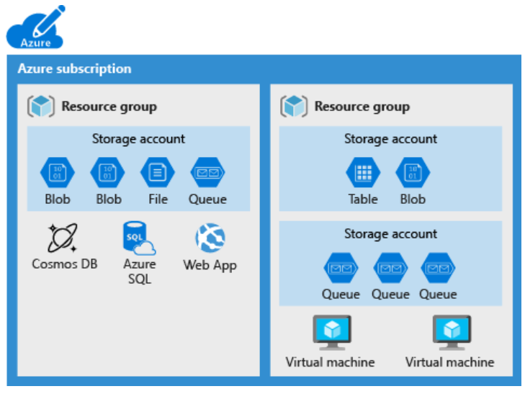

Storage account settings
Subscription , Location , Performance , Replication , Access tier , Secure transfer required , Virtual networks
The number of storage accounts you need is typically determined by your data diversity, cost sensitivity, and tolerance for management overhead.

Data diversity
Organizations often generate data that differs in where it is consumed, how sensitive it is, which group pays the bills, etc. Diversity along any of these vectors can lead to multiple storage accounts.
Do you have data that is specific to a country or region?
Do you have some data that is proprietary and some for public consumption?

Cost sensitivity
A storage account by itself has no financial cost; however, the settings you choose for the account do influence the cost of services in the account. Geo-redundant storage costs more than locally redundant storage. Premium performance and the Hot access tier increase the cost of blobs.

Tolerance for management overhead
Each storage account requires some time and attention from an administrator to create and maintain. It also increases complexity for anyone who adds data to your cloud storage;

Choose your account settings
- Name
- Deployment model
- Account kind

Account kind
Storage account kind is a set of policies that determine which data services you can include in the account and the pricing of those services. There are three kinds of storage accounts:
- StorageV2 (general purpose v2): the current offering that supports all storage types and all of the latest features
- Storage (general purpose v1): a legacy kind that supports all storage types but may not support all features
- Blob storage: a legacy kind that allows only block blobs and append blobs

c) Upload, download, and manage data with Azure Storage Explorer

What is Storage Explorer?
Storage Explorer is a GUI application developed by Microsoft to simplify access to, and the management of, data stored in Azure storage accounts. Storage Explorer is available on Windows, macOS, and Linux.
- It's easy to connect to and manage multiple storage accounts.
- The interface lets you connect to Azure Cosmos DB and Data Lake.
- You can also use the interface to update and view entities in your storage accounts.
- Storage Explorer is free to download and use.

Azure Storage types
Azure Storage Explorer can access many different data types from services like these:
- Azure Blob Storage. Blob storage is used to store unstructured data as a binary large object (blob).
- Azure Table Storage. Table storage is used to store NoSQL, semi-structured data.
- Azure Queue Storage. Queue storage is used to store messages in a queue, which can then be accessed and processed by applications through HTTP(S) calls.
- Azure Files. Azure Files is a file-sharing service that enables access through the Server Message Block protocol, similar to traditional file servers.
- Azure Data Lake Storage. Azure Data Lake, based on Apache Hadoop, is designed for large data volumes and can store unstructured and structured data.

Use local emulators
During the development phase of your project, you might not want developers to incur additional costs by using Azure storage accounts. In those cases, you can use a locally based emulator. Storage Explorer supports two emulators: Azure Storage Emulator and Azurite.
- Azure Storage Emulator uses a local instance of Microsoft SQL Server 2012 Express LocalDB. It emulates Azure Table, Queue, and Blob storage.
- Azurite, which is based on Node.js, is an open-source emulator that supports most Azure Storage commands through an API.

Connection types
There are many ways to connect an Azure Storage Explorer instance to your Azure resources. For example:
- Add resources by using Azure Active Directory (Azure AD)
- Use a connection string
- Use a shared access signature URI
- Use a name and key
- Attach to a local emulator
- Attach to Azure Cosmos DB through a connection string
- Attach to Azure Data Lake by using a URI

Connect Azure Storage Explorer to Azure Cosmos DB and Data Lake

d) Connect an app to Azure Storage

Microsoft Azure Storage is a managed service that provides durable, secure, and scalable storage in the cloud.

Data types in Azure storage services
Azure storage includes four types of data:
- Blobs: A massively scalable object store for text and binary data. Can include support for Azure Data Lake Storage Gen2.
- Files: Managed file shares for cloud or on-premises deployments.
- Queues: A messaging store for reliable messaging between application components.
- Table Storage: A NoSQL store for schema-less storage of structured data. Table Storage is not covered in this module.

Blobs
Azure Blob Storage is an object storage solution optimized for storing massive amounts of unstructured data, such as text or binary data. Blob Storage is ideal for:
Block blobs | Block blobs are used to hold text or binary files up to ~5 TB (50,000 blocks of 100 MB) in size. The primary use case for block blobs is the storage of files that are read from beginning to end, such as media files or image files for websites. They are named block blobs because files larger than 100 MB must be uploaded as small blocks. These blocks are then consolidated (or committed) into the final blob.
Page blobs | Page blobs are used to hold random-access files up to 8 TB in size. Page blobs are used primarily as the backing storage for the VHDs used to provide durable disks for Azure Virtual Machines (Azure VMs). They are named page blobs because they provide random read/write access to 512-byte pages.
Append blobs | Append blobs are made up of blocks like block blobs, but they are optimized for append operations. These blobs are frequently used for logging information from one or more sources into the same blob. For example, you might write all of your trace logging to the same append blob for an application running on multiple VMs. A single append blob can be up to 195 GB.

Files
Azure File storage enables you to set up highly available network file shares that can be accessed using the standard Server Message Block (SMB) protocol. This means that multiple VMs can share the same files with both read and write access. You can also read the files using the REST interface or the storage client libraries. You can also associate a unique URL to any file to allow fine-grained access to a private file for a set period of time.

Queues
Azure Queue Storage is used to store and retrieve messages. Queue messages can be up to 64 KB in size, and a queue can contain millions of messages. Queues are used to store lists of messages to be processed asynchronously.
You can use queues to loosely connect different parts of your application together. For example, we could perform image processing on the photos uploaded by our users.

Interact with the Azure Storage APIs

Use the REST API
The Storage REST APIs are accessible from anywhere on the Internet by any app that can send an HTTP/HTTPS request and receive an HTTP/HTTPS response.

For example, if you wanted to list all the blobs in a container, you would create a request something like:

GET https://[url-for-service-account]/?comp=list&include=metadata

Use a client library
Client libraries can save a significant amount of work for app developers because the API has been tested and often provides nicer wrappers around the data models sent and received by the REST API.
To work with data in a storage account, your app will need two pieces of data:
- Access key
- REST API endpoint

Connection strings
The simplest way to handle access keys and endpoint URLs within applications is to use storage account connection strings. A connection string provides all needed connectivity information in a single text string.

Security
Access keys are critical to providing access to your storage account, and as a result, should not be given to any system or person that you do not want to have access to your storage account. Access keys are the equivalent of a username and password to access your computer

Shared access signatures (SAS)
var connectionString = configuration.GetConnectionString("StorageAccount");
string containerName = "photos";
BlobContainerClient container = new BlobContainerClient(connectionString, containerName);

BlobClient blobClient = container.GetBlobClient(blobName);
blobClient.Upload(fileName, true);

e) Make your application storage highly available with read-access geo-redundant storage

Understand the role of an Azure storage account and its replication features

Let's see how an Azure storage account is configured to allow for replication and high availability of data.

Data redundancy
Data in Azure is replicated to ensure that it's always available, even if a datacenter or region becomes inaccessible or a specific piece of hardware fails. You have the following replication options:
- Locally redundant storage (LRS)
- Zone-redundant storage (ZRS)
- Geographically redundant storage (GRS)
- Read-access geo-redundant storage (RA-GRS)
- Geo-zone-redundant storage (GZRS)
- Read-access geo-zone-redundant storage (RA-GZRS)

What is locally redundant storage (LRS)
Locally redundant storage replicates data and stores three copies across fault domains, or racks of hardware, within a single datacenter facility in one region. Data is replicated so that if there's a hardware fault or maintenance work, your data is still available and accessible.

What is zone-redundant storage (ZRS)?

Zone-redundant storage replicates your data across three storage clusters in a region. Each cluster is physically separated from the other two, which means that each cluster is supplied by separate utilities, such as power or networking.

What is geographically redundant storage (GRS)?
Geographically redundant, or geo-redundant, storage provides multiple levels of replication. Your data is replicated three times within the primary region, and then this set is replicated to a secondary region.

GRS provides the highest level of durability, because you finish with six copies of your data. Such durability means that even if there's a datacenter failure or regional issues in the primary region, your data is always available.

What is read-access geo-redundant storage (RA-GRS)?
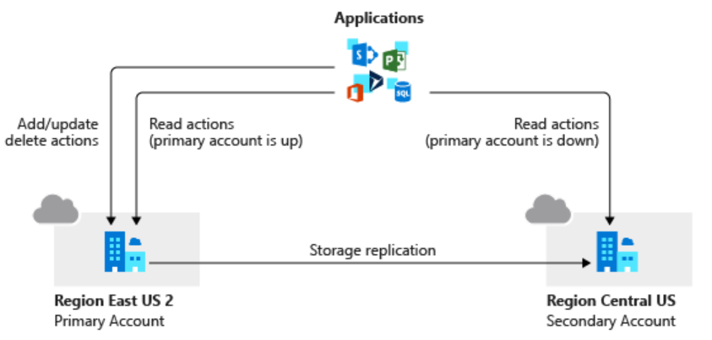

What is geo-zone-redundant storage (GZRS)?
Geo-zone-redundant storage (GZRS) combines the high availability benefits of ZRS with GRS. With this replication type, your data is copied across three availability zones in one region. Data is also replicated three times to another secondary region that's paired with it. This way, your zone-redundant data is also secure from regional level outage.

What is read-access geo-zone-redundant storage (RA-GZRS)?
Read-access geo-zone-redundant storage (RA-GZRS) uses the same replication method as GZRS but lets you read from the secondary region. If you want to read the data that's replicated to the secondary region, even if your primary isn't experiencing downtime, use RA-GZRS for your replication type.
Replication type | Copies | Use case
LRS | 3 | Data remains highly available, but for compliance reasons, isn't allowed to leave the local datacenter.
ZRS | 3 | Need redundancy in multiple physical locations, but because of compliance, data isn't allowed to leave a region.
GRS | 6 | App has access to the data, even if an entire region has an outage.
RA-GRS | 6 | App reads from multiple geographical locations, so you can serve users from a location that's closer to them.
GZRS | 6 | App can access data, even if the primary region has failed, and your secondary region has a datacenter that's experiencing an outage. But you don't want to read from the secondary region unless the primary region is down.
RA-GZRS | 6 | Regularly read data from your secondary region, perhaps to serve users from a location closer to them, even if a datacenter is up in your primary region.

az storage account show-connection-string \
--name $STORAGEACCT \
--resource-group [Sandbox resource group]

Design a resilient application
Resiliency , High availability , Disaster recovery , Eventual consistency

Best practices for cloud-based applications with RA-GRS

Retry transient failures

Handle failed writes
RA-GRS replicates writes across locations. If the primary location fails, you can direct read operations toward the secondary location. However, this secondary location is read-only. If a long-lasting outage (more than a few seconds) occurs at the primary location, your application must run in read-only mode. You can achieve read-only mode in several ways
An application that uses the Azure Storage client library can set the LocationMode of a read request to one of the following values:
- PrimaryOnly: The read request fails if the primary location is unavailable. This failure is the default behavior.
- PrimaryThenSecondary: Try the primary location first, and then try the secondary location if the primary location is unavailable. Fail if the secondary location is also unavailable.
- SecondaryOnly: Try only the secondary location, and fail if it's not available.
- SecondaryThenPrimary: Try the secondary location first, and then try the primary location.

Use the Circuit Breaker pattern
In distributed environments, communication between remote resources can fail because of slow network connections, resources timeouts, resources being offline, or a transmission problem corrupting data in transit. Most of the time, these issues are transient and resolve themselves. If the application retries the same operation, it often succeeds.

f) Secure your Azure Storage account

Explore Azure Storage security features

- Protect the data at rest
- Protect the data in transit
- Support browser cross-domain access
- Control who can access data
- Audit storage access

Encryption at rest
All data written to Azure Storage is automatically encrypted by Storage Service Encryption (SSE) with a 256-bit Advanced Encryption Standard (AES) cipher, and is FIPS 140-2 compliant. SSE automatically encrypts data when writing it to Azure Storage. When you read data from Azure Storage, Azure Storage decrypts the data before returning it. This process incurs no additional charges and doesn't degrade performance. It can't be disabled.

Encryption in transit
Keep your data secure by enabling transport-level security between Azure and the client. Always use HTTPS to secure communication over the public internet. When you call the REST APIs to access objects in storage accounts, you can enforce the use of HTTPS by requiring secure transfer for the storage account.

CORS support
Contoso stores several website asset types in Azure Storage. These types include images and videos. To secure browser apps, Contoso locks GET requests down to specific domains.

Role-based access control
To access data in a storage account, the client makes a request over HTTP or HTTPS. Every request to a secure resource must be authorized. The service ensures that the client has the permissions required to access the data. You can choose from several access options. Arguably, the most flexible option is role-based access.

Auditing access
Auditing is another part of controlling access. You can audit Azure Storage access by using the built-in Storage Analytics service.
Storage Analytics logs every operation in real time, and you can search the Storage Analytics logs for specific requests. Filter based on the authentication mechanism, the success of the operation, or the resource that was accessed.

Types of shared access signatures
You can use a service-level SAS to allow access to specific resources in a storage account. You'd use this type of SAS, for example, to allow an app to retrieve a list of files in a file system, or to download a file.
Use an account-level SAS to allow access to anything that a service-level SAS can allow, plus additional resources and abilities. For example, you can use an account-level SAS to allow the ability to create file systems.

Explore security anomalies
When storage activity anomalies occur, you receive an email notification with information about the suspicious security event. Details of the event include:
- Nature of the anomaly
- Storage account name
- Event time
- Storage type
- Potential causes
- Investigation steps
- Remediation steps
- Email also includes details about possible causes and recommended actions to investigate and mitigate the potential threat

Explore Azure Data Lake Storage security features

g) Choose the right disk storage for your virtual machine workload

Managed, unmanaged, and local disk storage

Disk roles
Each disk can take one of three roles in a virtual machine:
- OS disk. One disk in each virtual machine contains the operating system files. When you create a virtual machine, you select a virtual machine image and that fixes the operating system and the OS disk that's attached to the new machine. The OS disk has a maximum capacity of 4 TB.
- Data disk. You can add one or more data virtual disks to each virtual machine to store data. For example, database files, website static content, or custom application code should be stored on data disks. The number of data disks you can add depends on the virtual machine size. Each data disk has a maximum capacity of 32,767 GB.
- Temporary disk. Each virtual machine contains a single temporary disk, which is used for short-term storage applications such as page files and swap files. The contents of temporary disks are lost during maintenance events, so don't use these disks for critical data. These disks are local to the server and aren't stored in a storage account.
You can administer OS disks and data disks on the Disks page of the virtual machine in the Azure portal.
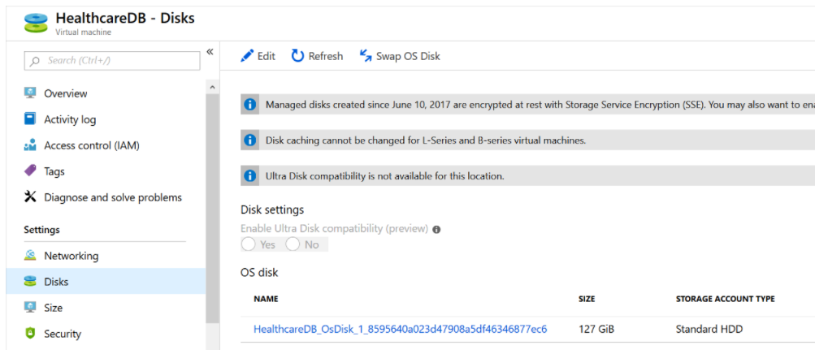

Ephemeral OS disks
An ephemeral OS disk is a virtual disk that saves data on the local virtual machine storage. An ephemeral disk has faster read-and-write latency than a managed disk. It's also faster to reset the image to the original boot state if you're using an ephemeral disk.

Managed disks
Most disks that you use with virtual machines in Azure are managed disks. A managed disk is a virtual hard disk for which Azure manages all the required physical infrastructure. Because Azure takes care of the underlying complexity, managed disks are easy to use. You can just provision them and attach them to virtual machines.
The benefits of managed disks include
Simple scalability , High availability , Integration with availability sets and zones , Support for Azure Backup , Granular access control , Support for encryption

Unmanaged disks
An unmanaged disk, like a managed disk, is stored as a page blob in an Azure Storage account. The difference is that with unmanaged disks, you create and maintain this storage account manually. This requirement means that you have to keep track of IOPS limits within a storage account and ensures that you don't overprovision throughput of your storage account. You must also manage the security and RBAC access at the storage account level, instead of at each individual disk with managed disks.

Disk types for virtual machines

Disk performance measures
To choose the right disk type, it's critical to understand its performance. Performance is expressed in two key measures:
- Input/output operations per second (IOPS). IOPS measure the rate at which the disk can complete a mix of read and write operations. Higher performance disks have higher IOPS values.
- Throughput. Throughput measures the rate at which data can be moved onto the disk from the host computer and off the disk to the host computer.

Ultra Disks
Ultra Disks provide the highest disk performance available in Azure. Choose them when you need the fastest storage performance, which includes high throughput, high IOPS, and low latency.

Premium SSD
Premium SSDs are the next tier down from Ultra Disks in terms of performance, but they still provide high throughput and IOPS with low latency. Premium disks don't have the current limitations of Ultra Disks. For example, they're available in all regions and can be used with virtual machines that are outside of availability zones.

Standard SSD
Standard SSDs in Azure are a cost-effective storage option for virtual machines that need consistent performance at lower speeds. Standard SSDs aren't as fast as premium or Ultra Disks

Standard HDD
If you choose to use Standard HDDs, data is stored on conventional magnetic disk drives with moving spindles. Disks are slower and speeds are more variable than for SSDs

Select a disk type for your workload
The highest performance disks in Azure are premium SSDs and ultra SSDs. However, ultra disks don't currently support virtual machine images.

h) Monitor, diagnose, and troubleshoot your Azure storage

Azure portal
The Azure portal gives you a graphical way to view and monitor storage performance in near real time. There can be a delay of a few minutes between capturing data and it appearing on the Azure portal. In the Azure portal, you can:
- Configure metrics and logging.
- View graphs and charts, and select which metrics to visualize.
- Assess how your applications are doing over some time.
- Configure alerts to notify you of any behavior that is out of the ordinary.

Azure Storage Explorer (desktop version)
The desktop version of Azure Storage Explorer gives you another way to view the logs and metrics gathered by Azure Storage Analytics. The $Metrics tables and the $logs container are all accessible in Storage Explorer, and you can export the data, including the metrics in the $Metrics tables, to a folder on your desktop computer.

AzCopy
You can download the storage account logs to your local computer by using the AzCopy utility, or the desktop version of Azure Storage Explorer. You can then analyze this data by using analysis tools on your desktop.

Understand Storage Analytics metrics

Transaction metrics
Storage operations are transactional. If a write operation fails, its effects are undone. If a write succeeds, the changes are committed to storage. The metrics summarize information about each type of request, whether it's a read, a write, or a delete operation, and whether the operation succeeded or failed, and if it failed, what error occurred.

Capacity metrics
Capacity metrics are only available for blob storage. Capacity data is sent to the analytics service hourly, but the aggregated statistics are only updated daily.
The statistics reported are:
- Capacity, which records the sum total of the storage occupied by the blobs in your storage account.
- Container count, which shows how many containers have been created across blob storage in your storage account.
- Object count, which displays the total number of blobs created across all of your containers.

Capture Storage Analytics metrics
Storage Analytics records aggregated transaction statistics and capacity data, about requests made to the Azure Storage service. The metrics data is stored in a set of tables in your storage account. Each table is named after the type of storage monitored and whether the transaction occurred in primary or secondary storage.
Using the Azure portal. Select Diagnostic settings (classic) on the page for your storage account, select the storage type and change the Status to On or Off as required. By default, the data captured includes the metrics for each type of storage API call. You can also set the retention period for the metrics data. When this period expires, the metrics are deleted from table storage.
The Set-AzureStorageServiceMetricsProperty cmdlet enables you to enable and disable metrics capture for each type of storage in your account.
Using the Azure CLI. Use the az storage metrics update command

View Storage Analytics metrics
As described earlier, you can view the metrics gathered for a storage account using the Metrics page for the account in the Azure portal. This pane displays the information captured by Azure Monitor. This data is managed separately and isn't derived from the statics held in the $Metrics tables in your storage account.
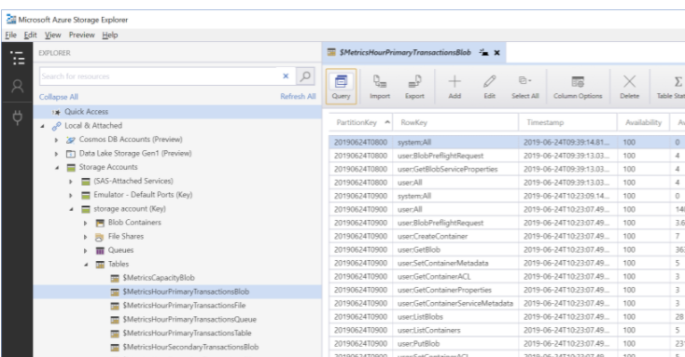
Microsoft provides the WindowsAzure.Storage client library that you can use to retrieve the metrics for a storage account. The key class in this library is CloudAnalyticsClient. You can use this class to run queries over the metrics held in the $Metrics tables.
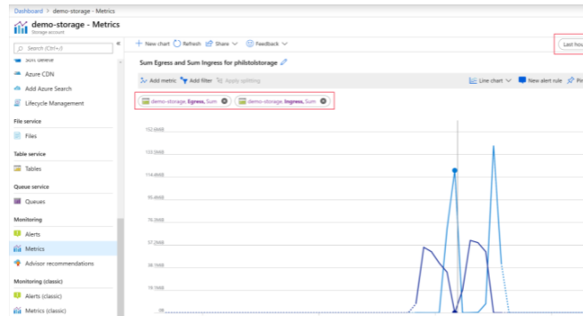

Azure Storage Analytics logging
Storage Analytics logs detailed information about requests to your storage service. This information is used to monitor individual requests and to diagnose issues with a storage service. Log entries are created when requests are made against the service endpoint. However, requests are recorded on a best effort basis. Occasionally, a small number of requests might not be logged, and others might be duplicated. You shouldn't treat the log as a definitive list of operations, rather a means of examining the workload for the storage account.
Storage Analytics logs record authenticated and anonymous requests made to a storage account. The following types of authenticated requests are logged:
- Successful requests
- Failed requests, including timeout, throttling, network, authorization, and other errors
- Requests using a Shared Access Signature (SAS) or OAuth, including failed and successful requests

Enable Storage Analytics logging
Unlike Storage Analytics metrics, Storage Analytics logging isn't enabled by default for your storage account. You can enable it in the Azure portal, from the Diagnostic settings (classic) page.
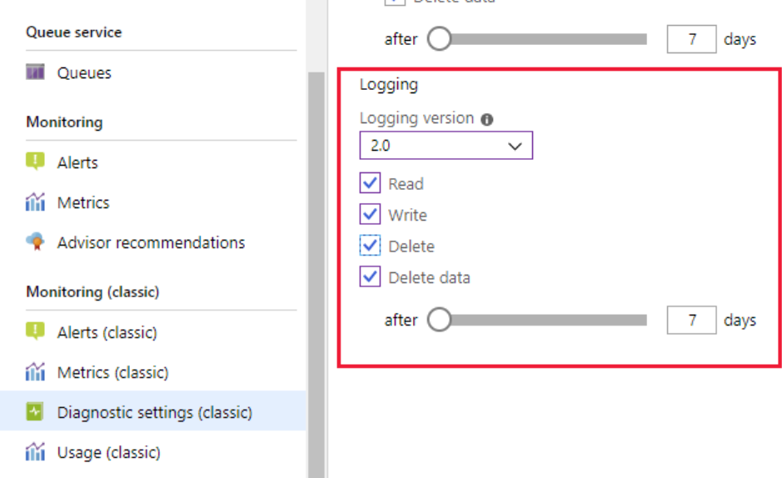
Under Storage Accounts, under your storage account, expand Blob Containers, and you should see a container named $logs, with a folder named blob. If this container doesn't appear, wait for a few minutes while Storage Analytics processes the log data, and then select Refresh in the toolbar.

